Documentation liens Simulink-IHM :

<https://www.mathworks.com/matlabcentral/answers/481469-app-designer-linked-to-simulink>

Généralités Digital Twins :

<https://www.mathworks.com/discovery/digital-twin.html#why-digital-twins-matter>

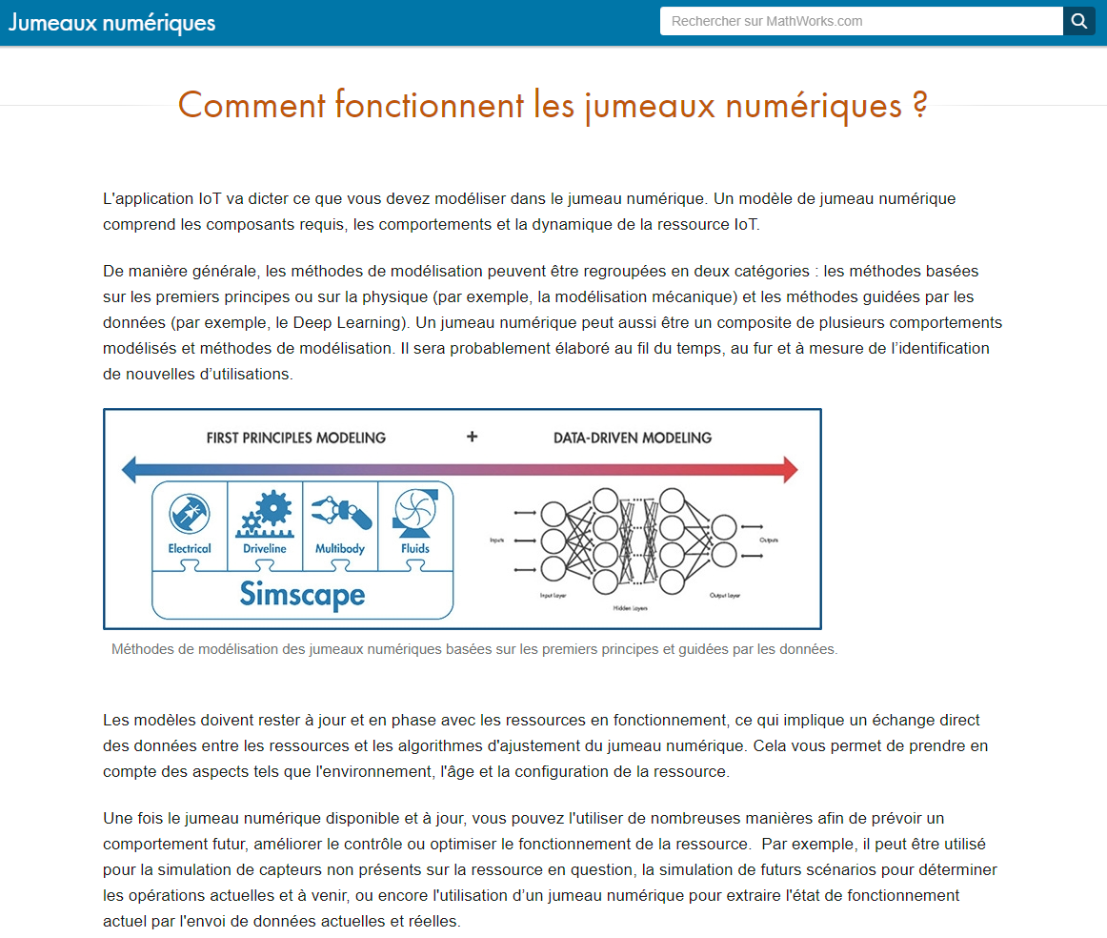

Prise en main de Simscape pour la simulation mécatronique du jumeau numérique :

<https://www.mathworks.com/videos/simscape-overview-61215.html>

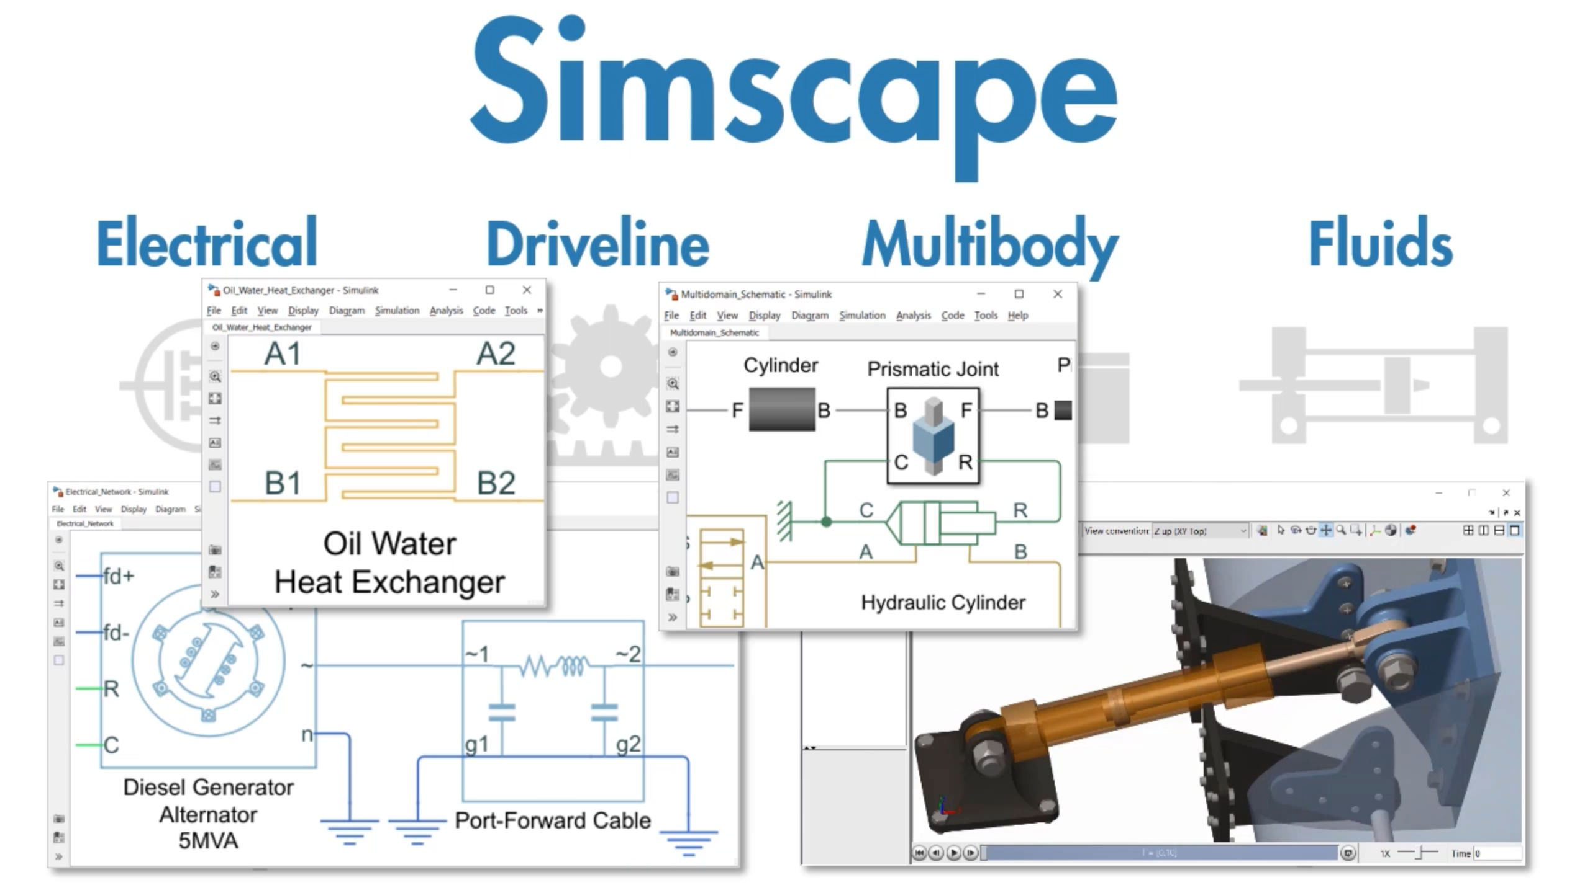

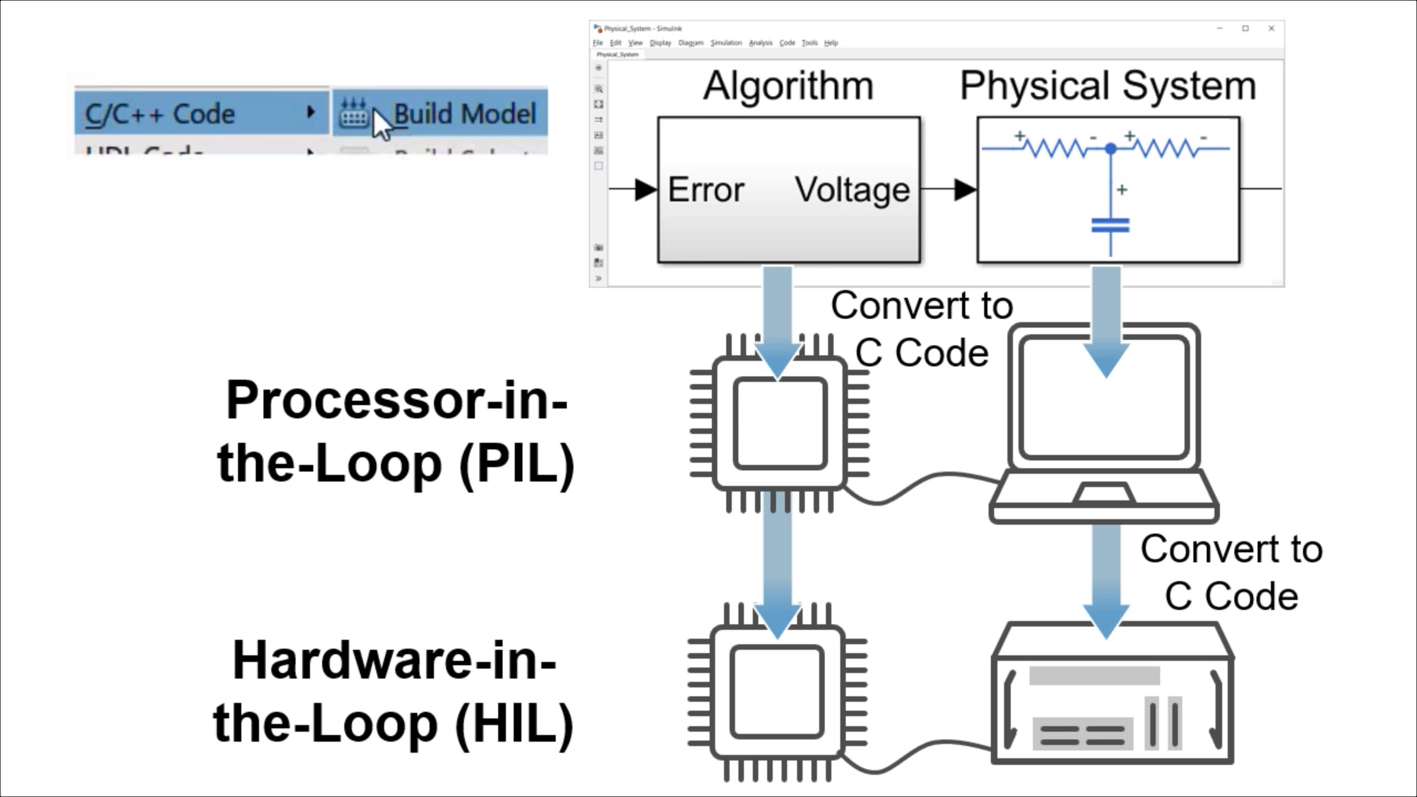

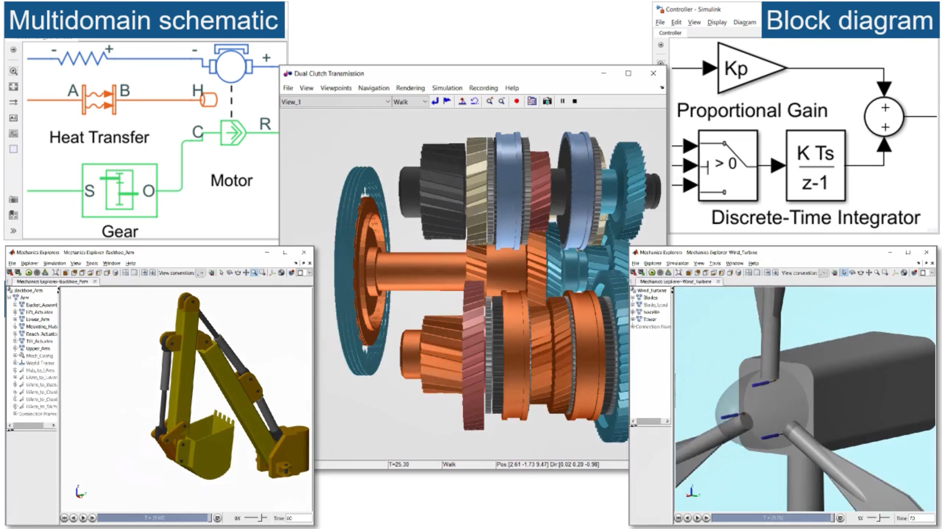

**EXEMPLE Hardware In the Loop VOLVO:**

[**https://www.mathworks.com/company/user_stories/volvo-construction-equipment-streamlines-product-development-with-a-real-time-human-in-the-loop-simulator.html**](https://www.mathworks.com/company/user_stories/volvo-construction-equipment-streamlines-product-development-with-a-real-time-human-in-the-loop-simulator.html)

* Modules nécessaires :
  + Simscape ?
  + Simscape multibody ?

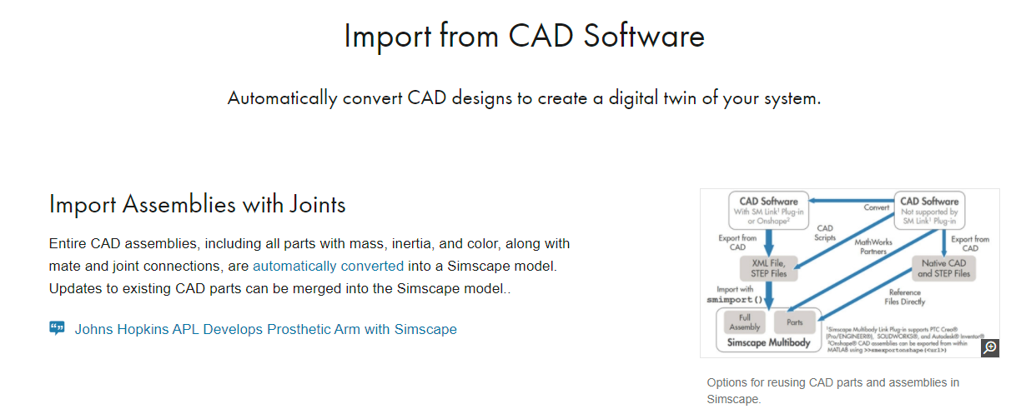

**Model-Based Design :**

[**https://www.mathworks.com/solutions/model-based-design.html**](https://www.mathworks.com/solutions/model-based-design.html)

**& Embedded Code Generation :**

[**https://www.mathworks.com/solutions/embedded-code-generation.html**](https://www.mathworks.com/solutions/embedded-code-generation.html)

* Exemple d’un modèle remplaçant la fonction de la boucle de retour avec capteur en modélisant mathématiquement/physiquement le comportant censé être obtenu :

<https://www.mathworks.com/videos/b-r-develops-virtual-sensor-technology-to-improve-servo-drive-performance-1490385615790.html>

avec : <https://www.mathworks.com/company/user_stories/br-industrial-automation-improves-servo-drive-performance-with-virtual-sensor-algorithms-developed-using-model-based-design.html>

**Mapping avec Matlab-Simulink :**

<https://www.google.com/search?client=avast&q=mapping+matlab+simulink>

**Toolboxes en lien :**

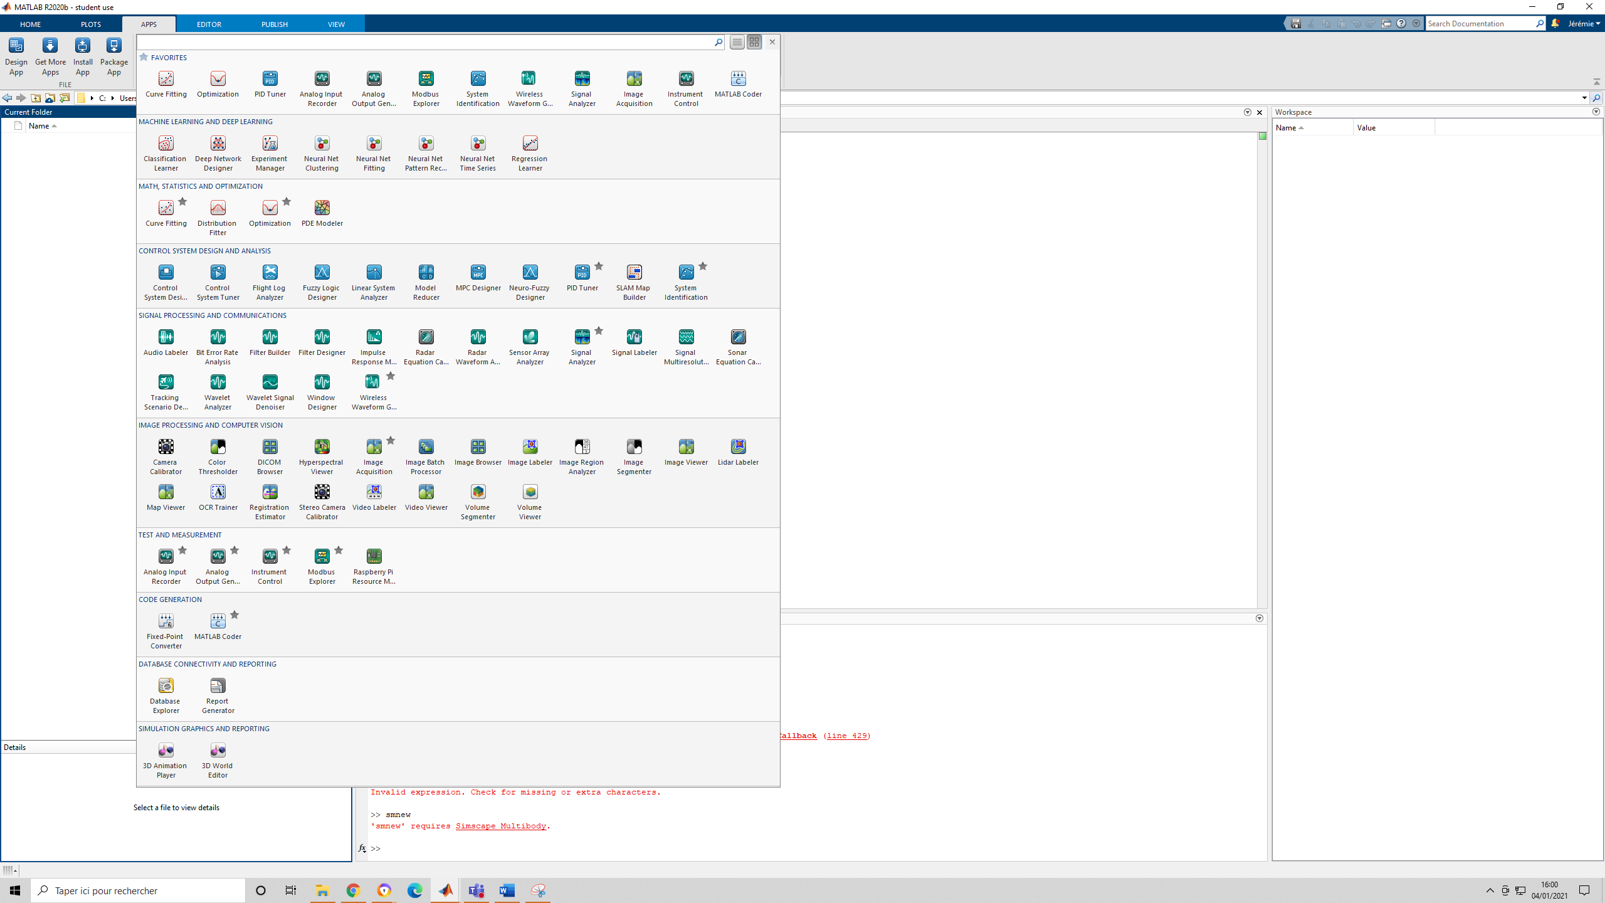

* Mapping : <https://fr.mathworks.com/help/releases/R2020b/map/ref/mapview.html>
* Mobile robotics : <https://fr.mathworks.com/matlabcentral/fileexchange/66586-mobile-robotics-simulation-toolbox>
* Github repo : <https://github.com/mathworks-robotics/mobile-robotics-simulation-toolbox>

**TUTORIEL :**

[**https://fr.mathworks.com/matlabcentral/fileexchange/66586-mobile-robotics-simulation-toolbox**](https://fr.mathworks.com/matlabcentral/fileexchange/66586-mobile-robotics-simulation-toolbox)

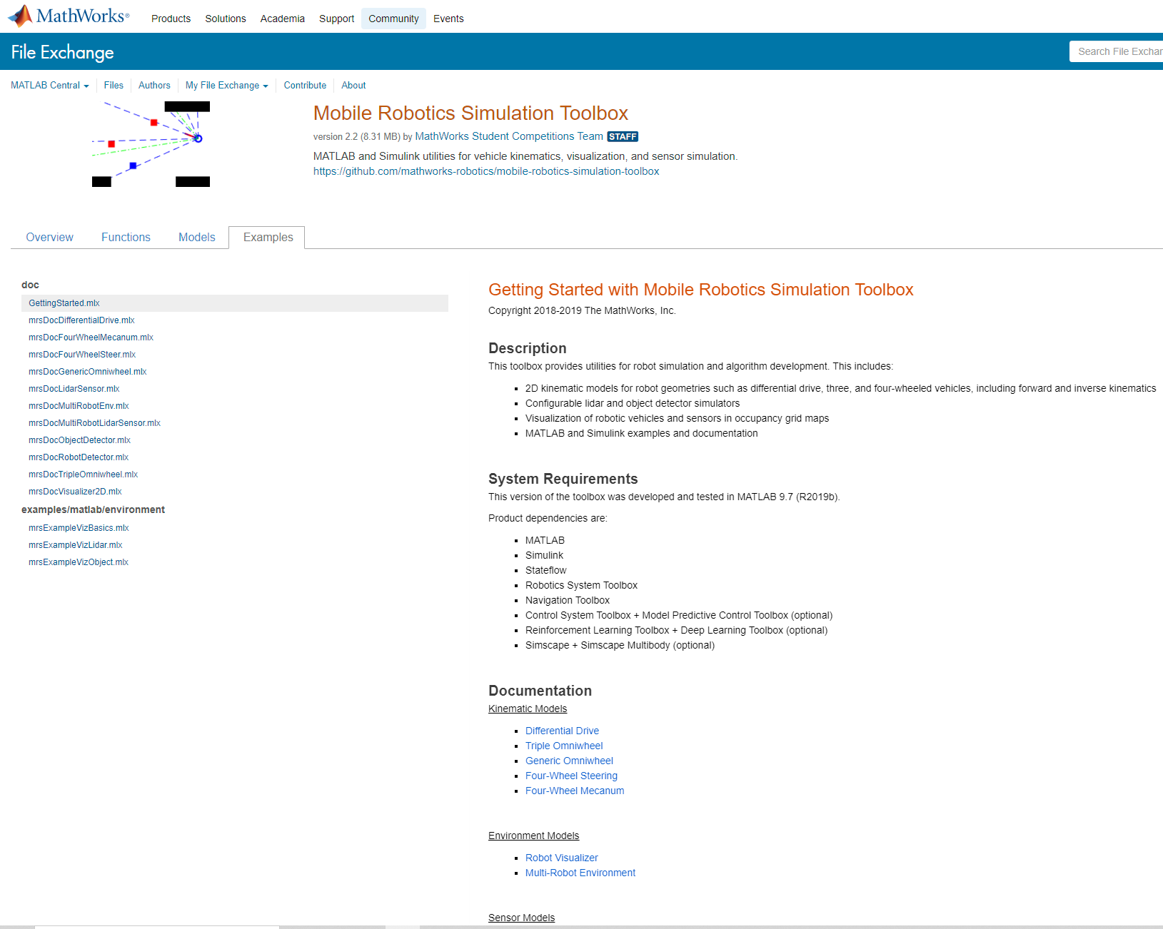

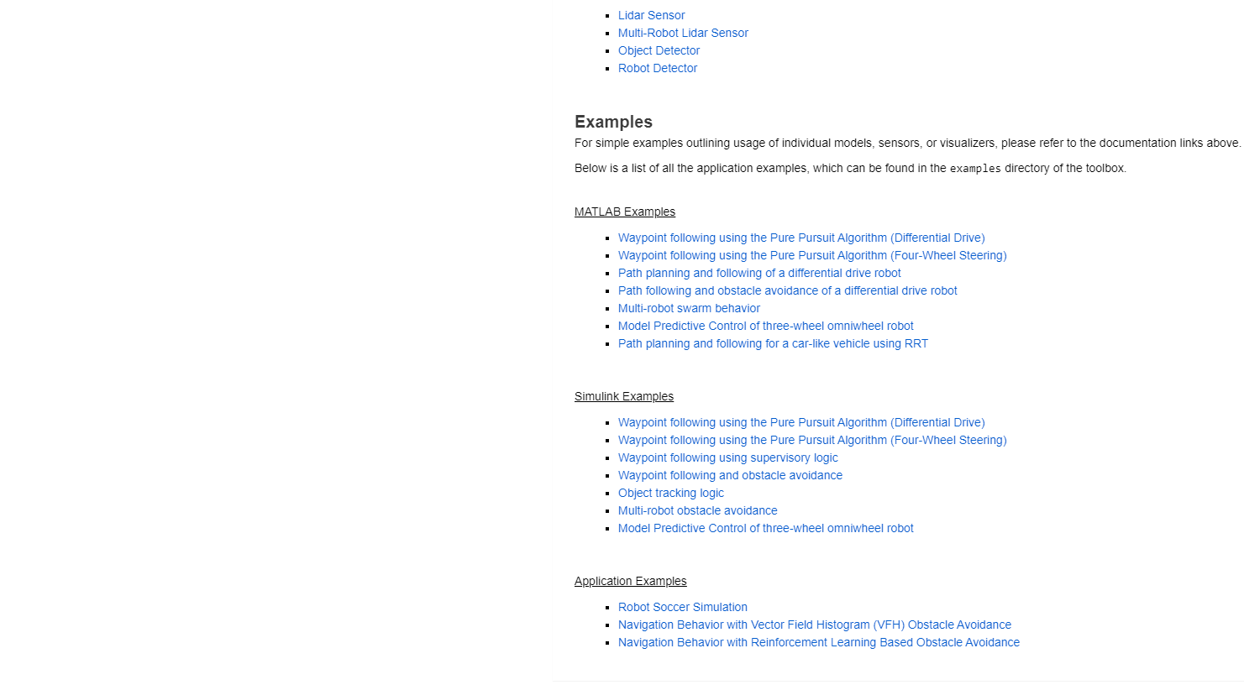

**Mise en œuvre Raspberry Pi ⬄ Matlab :**

